Enterprise AI Decision Intelligence Platform – Complete Development Flow (AI-Assisted Development)
This is the implementation roadmap for our project. The order below is not the same as the report module order. It is arranged based on practical software development so that each module has the required foundation before the next module is developed.
The goal is to use AI tools (Antigravity, ChatGPT, Gemini, Claude, Copilot, etc.) to accelerate development while keeping the architecture aligned with the project proposal.

Phase 0 – Project Planning & Architecture Setup
Objective
Before writing any code, establish the complete architecture so that every team member works on the same structure. This phase defines the overall project organization, technology stack, development workflow, and communication between modules.

What we will develop
- Finalize the complete system architecture.
- Divide the project into frontend, backend, AI modules, and databases.
- Create the Git repository and branching strategy.
- Create the Django project and React application.
- Configure PostgreSQL as the primary database.
- Configure MongoDB for document storage.
- Prepare Docker (optional if time permits).
- Create the folder structure for every module.
- Define REST API communication between frontend and backend.
- Create the basic authentication system.
- Configure environment variables.
- Prepare reusable utility functions.
- Create logging and error handling.

Expected Output
A complete project skeleton where every module can be developed independently without affecting others.

Phase 1 – Enterprise Data Collection & Ingestion
Objective
This module is the entry point of the entire system. Every enterprise file enters the platform through this module. Since enterprise data comes in different formats, the module converts all incoming information into a standardized structure before any AI processing begins.

What we will develop
Develop a secure upload system that allows users to upload enterprise documents from different sources.
Supported file types include:
- PDF
- Excel
- CSV
- Images
- Text files
- JSON
- Enterprise APIs
When a file is uploaded, the system should automatically identify its type and process it using the appropriate parser.
For every uploaded document:
- Read the content.
- Extract readable text.
- Extract metadata.
- Extract document properties.
- Identify document source.
- Convert different formats into one common enterprise format.
If the uploaded document is an image:
- Perform OCR.
- Extract text.
- Store extracted information.
If the uploaded document is a PDF:
- Extract pages.
- Extract tables.
- Extract text.
For Excel:
- Read worksheets.
- Convert rows into structured records.
All extracted information should then be converted into one standardized enterprise data model.
Finally, save:
- Original document
- Parsed content
- Metadata
- Standardized enterprise record

Expected Output
A standardized enterprise dataset that can be processed by all downstream AI modules.

Phase 2 – Enterprise Knowledge Repository
Objective
Once enterprise data has been standardized, it must be stored properly so that every future module can access it.
This phase builds the central knowledge repository of the system.

What we will develop
Store structured information inside PostgreSQL.
Store semi-structured document content inside MongoDB.
Generate unique document IDs.
Maintain document versions.
Maintain upload history.
Maintain metadata.
Organize enterprise records.
Implement document retrieval APIs.
Implement secure CRUD operations.
Implement repository management.
Prepare storage architecture for future Knowledge Graph integration.
Prepare storage architecture for future Vector Database integration.

Expected Output
A centralized enterprise knowledge repository capable of storing all processed enterprise information.

Phase 3 – Business Intelligence Dashboard (Foundation)
Objective
Before implementing AI, build the dashboard structure that visualizes system activity.
Initially, the dashboard will display repository information instead of AI predictions.

What we will develop
Create React dashboard pages.
Develop:
- Dashboard Home
- Document Management
- Upload Status
- Repository Statistics
- User Activity
- File Analytics
Display:
- Total uploaded files
- File types
- Total users
- Upload history
- Processing status
- Storage statistics
Develop reusable dashboard components.
Prepare dashboard sections that will later display AI outputs.

Expected Output
A fully functional enterprise dashboard connected to backend APIs.

Phase 4 – Enterprise Data Quality Intelligence (EDQI)
Objective
Before enterprise knowledge enters the repository permanently, evaluate its quality using Machine Learning.
This module ensures that unreliable data does not affect enterprise decision-making.

What we will develop
Build the complete data quality pipeline.
Every standardized record should pass through the validation engine.
The system should automatically analyze records and classify them into:
- Clean
- Duplicate
- Incomplete
- Invalid
- Suspicious
Implement preprocessing.
Prepare training dataset.
Train Machine Learning model.
Evaluate model performance.
Generate prediction APIs.
Store prediction results.
Maintain confidence scores.
Display classification results on dashboard.

Algorithms
- Random Forest
- XGBoost
- Isolation Forest

Expected Output
Only reliable enterprise records proceed to the next module.

Phase 5 – Enterprise Knowledge Conflict Detection (EKCD)
Objective
Even if enterprise data is clean, different documents may contain conflicting information.
This module identifies inconsistent enterprise knowledge before storage.

What we will develop
- Extract textual knowledge.
- Split documents into meaningful sentences.
- Generate sentence embeddings.
- Compare semantic similarity.
Detect:
- Duplicate knowledge
- Contradictory knowledge
- Outdated knowledge
Compare document timestamps.
Identify latest version.
Generate conflict reports.
Generate confidence scores.
Store conflict analysis.
Display conflicts inside dashboard.

Algorithms
- Sentence Transformers
- DistilBERT
- MiniLM
- Cosine Similarity

Expected Output
Enterprise knowledge becomes consistent and trustworthy before entering AI retrieval.

Phase 6 – Enterprise Knowledge Assistant (RAG + Local LLM)
Objective
Build an enterprise chatbot that answers questions using only the organization's validated knowledge.
The assistant should retrieve relevant enterprise documents before generating responses.

What we will develop
Prepare enterprise documents for semantic search.
Split documents into chunks.
Generate embeddings.
Store embeddings inside the vector database.
Implement semantic search.
Retrieve top relevant documents.
Retrieve related knowledge from the Knowledge Graph (initially this can be kept as a placeholder if graph integration comes slightly later).
Construct context from retrieved enterprise knowledge.
Pass the context to the local LLM.
Generate enterprise-specific responses.
Display:
- Retrieved documents
- Source references
- Generated answer
Maintain conversation history.

Technologies
- LangChain
- Ollama
- Llama 3
- FAISS
- Neo4j (integration when the Knowledge Graph is implemented)

Expected Output
Users can ask enterprise questions and receive context-aware answers grounded in validated enterprise knowledge.

Phase 7 – AI-Based Policy Impact Simulator
Objective
Predict how organizational policy changes may affect the enterprise before implementation.
This module provides explainable decision support rather than simple predictions.

What we will develop
Prepare historical policy dataset.
Perform feature engineering.
Train Machine Learning model.
Predict future policy impact.
Generate feature importance.
Integrate SHAP explanations.
Allow users to modify policy parameters.
Generate prediction reports.
Display prediction charts.
Store prediction history.
Compare previous simulations.

Algorithms
- Random Forest
- XGBoost
- SHAP

Expected Output
Decision-makers can evaluate policy changes with transparent AI explanations.

Phase 8 – Real-Time Data Streaming & Processing
Objective
After the complete system works in a synchronous manner, convert it into a near real-time enterprise platform.
This module improves scalability and responsiveness without changing the core business logic.

What we will develop
Integrate Redis.
Configure Celery.
Create background workers.
Move document processing into asynchronous tasks.
Queue uploaded documents.
Execute parsing in background.
Execute OCR in background.
Execute metadata extraction in background.
Execute preprocessing in background.
Schedule periodic synchronization using Celery Beat.
Implement task monitoring.
Implement retry mechanisms for failed tasks.
Update dashboard with task status.

Expected Output
The system processes newly arriving enterprise data asynchronously while users continue working without waiting for long-running operations to complete.

Final Integrated System Flow
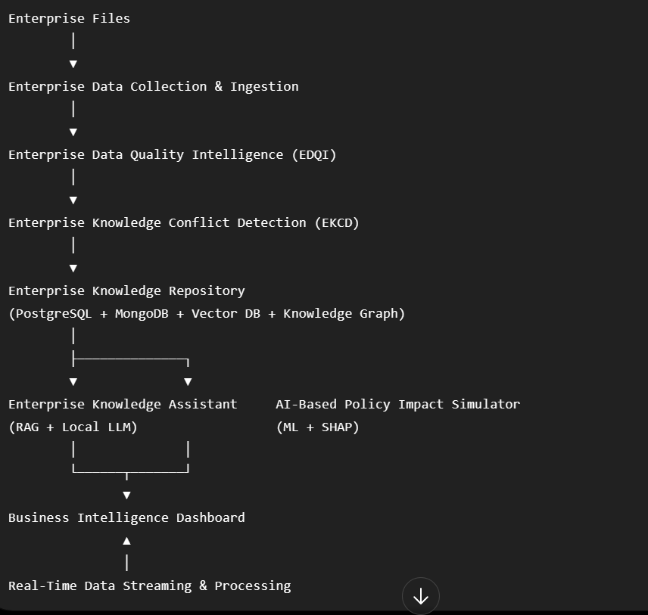Development Note
This roadmap is intentionally ordered for implementation efficiency, not according to the report chapter sequence. Each phase builds the required foundation for the next, allowing your three-member team to develop modules in parallel where possible while keeping integration straightforward.

